**CONVERSION OF SCRAP BIKE TO ELECTRIC BIKE WITH REGENERATIVE BRAKING SYSTEM BY HBTU KANPUR STUDENTS**

**INTRODUCTION:**

E-Bikes are considered the most eco-friendly mode of vehicles as compared to vehicles that use fossil fuels. Electric vehicles emit no combustion which will not only help us but it will also ensure and give freedom to survive freely in open air to upcoming generations. Due to this reason it is going to become the fastest means of transport in the upcoming future. With the character of being eco-friendly, it is economically feasible too for lower class people of the society. In various articles and editorials, we came across that the greatest opportunity is for rural and

suburban areas. This will lead to awareness of technological development in these areas and give a chance to move abroad as most of the people of such areas are restricted to that particular zone and don't get a chance to see the outer world.

Due to decrease in fossil reserves and increase in price of petrol it is not possible for everyone in society to make a bike his “Lazy noon cup of tea” but they can make an E-Bike. If we see insights of the survey presented before the country by the parliament; the E-Bikes market in India is estimated to reach value of INR 17.43 Bn by FY2024, from INR 2.92 Bn in FY 2019, expanding at a compound annual growth rate (CAGR) of 42-43% during the FY - 2020 - FY 2024 period.



The 1st prototype of this project was prepared from an old condemned motorcycle. The First and foremost step was to remove the old petrol engine from the bike along with other peripherals of petrol combustion like carburettor, fuel tank assembly etc. After this our primary objective was to prepare a space for the installation of an Electric motor. To maintain the balance of the motorcycle, the electric motor was placed at the nearest possible distance from the centre of gravity of the motorcycle chassis. We will be using the old drive chain and chain sprocket of the motorcycle. Next task is to find space for battery installation. This was done by hollowing the fuel tank from inside and placing the batteries under it. The space which was earlier used for air filters will be used for electric motor drive controller installation. The accelerator of the motorcycle was replaced by an electric motor throttle controller and the speedometer console was replaced by an electric console displaying the speed of the e-bike, a battery indicator on/off display and other indicators.

The 2nd prototype will be the upgradation of 1st prototype, to increase the speed of the bike we will replace normal BLDC motor with BLDC hub motor that will fix directly in the rim of the tyre. Secondly, this prototype will come with Regenerative Braking System that will increase the efficiency of the bike upto 40%. Other features of the prototype will include GPS system and Bluetooth system that will help to connect bike with your phone which helps in tracking , emergency and traffic control.

**OBJECTIVE:**

The present project aims **to retain the environment friendly atmosphere** of the villages which is declining day by day. Our electric bike project can play a critical role in that. This will also aim to reduce the use of tractors, which produce smog of harmful gases and as a means of transportation in most of the villages.

Being the students of H.B.T.U., Kanpur we also aim to launch these bikes in college for students to travel from college hostels i.e. West Campus to main college building i.e. East Campus (Approx. Distance 4km) where all the academic and other activities go on. These are not only economical but also good for environmental conditions.

We also know that the vehicles of Standard BS-III & BS-IV will not be registered by RTO again after completion of 15 years & 10 Years for petrol and diesel respectively. Therefore, these vehicles will become scrap as most of the parts are not usable. Thus, the amount of waste will increase exponentially in our country. So to utilise them **we will convert these bikes into E-Bikes**

**CURRENT STATUS:**

Villages do not have corporate office work culture and basically villagers indulge in farming, agriculture, and small businesses. Lower densities of rural areas imply longer distances between activity locations. To promote and sustain their small businesses, they need to travel to towns and cities to get hold of their raw materials and products. A vast majority of them travel through public transport such as buses and trains which do not usually run frequently. Although they also use bikes which are too costly for the majority of the population, even some people take the chance to buy, which persuades them to take loans from banks and indulge them into debt.

In similar manner students who travel from West campus to East campus either have to keep their own bikes/scooters or they have to look for an E-rickshaw which is not economically feasible for every student. Due to this problem some students miss class, some don't go back to have lunch, some don't come up to take part in extra co-curricular activities.

**EXPECTED SOLUTION:**

While the government has come up with EV subsidy programs, it is FAME (Faster Adoption and Manufacturing of Electric Vehicle) that has facilitated in driving the adoption of electric-scooters on Indian roads. Nowadays, a new era of E-vehicles i.e. electric vehicles has started and is also playing a very important role in the convenience of people & economic growth of our country. E-vehicles are eco-friendly & more silent as compared to petrol or diesel engine powered vehicles which also emit a large number of harmful gases for

example, carbon monoxide, nitrogen oxides, hydrocarbons, suspended particulate matter, and a small amount of sulphur dioxide. As compared to petrol engines, an electric vehicle has high pick up and no- gear transmission is required. It is cost effective and low maintenance is required. These electric vehicles match the guidelines of Environmental considerations by the government. So our motive is to use pre-existing or discarded bikes as our prototype's primary body structure and convert it into a useful electric bike. Our whole emphasis will be to make it budget & environment friendly. This initiative will be beneficial for our university students as well as for rural people. We'll also establish charging stations in

both the campuses and the rural areas as the villages now have over 15 hours of power supply in most cases, thus charging an electric vehicle can be easily done. In future we'll expand our idea at City level keeping in view the climate change commitments made by the govt. of India, it is pertinent to introduce alternate means in the transport sector.

**NOVELTY OF PROJECT:**

In 2021, fuel prices were the highest ever in recorded Indian history. This severely impacted the pocket of the middle and poor population. The impact was also witnessed in the rural areas. The cost of charging an electric bike’s battery would be 1/10th of the cost of fuel in a normal motorcycle. This would subsequently mean that by using electric vehicles, the rural electric bike owner can save 90% of his or her money. As we are making this E-Bike from the useless bikes which are sold as scrap, it will cost 20-30% less than the actual price of the new E-Bike and our bike can be modified according to the demand that will not let anyone feel that it’s an old bike. Even till now some renowned companies haven't launched their bikes in the market because of this price problem.

**PROTOTYPE DESIGN**

**1st prototype:** The prototype of this project is being prepared from an old condemned motorcycle. The First and foremost step was to remove the old petrol engine from the bike along with other peripherals of petrol combustion like carburettor, fuel tank assembly etc. After this our primary objective was to prepare a space for the installation of an Electric motor. To maintain the balance of the motorcycle, the electric motor was placed at the nearest possible distance from the centre of gravity of the motorcycle chassis. We will be using the old drive chain and chain sprocket of the motorcycle. Next task is to find space for battery installation. This will be done by hollowing the fuel tank from inside and placing the batteries under it. The space which was earlier used for air filters will be used for electric motor drive controller installation. The accelerator of the motorcycle will be replaced by an electric motor throttle controller and the speedometer console will be replaced by an electric console displaying the speed of the e-bike, a battery indicator on/off display and other indicators.

**2nd prototype:** This prototype of E-bike is the upgraded version of the 1st prototype. The main features of this prototype are:

>> Use of HUB MOTOR -  BLDC Motor operation is based on the**attraction or repulsion between magnetic poles**. Using the three-phase motor as shown in figure below, the process starts when current flows through one of the three stator windings and generates a magnetic pole that attracts the closest permanent magnet of opposite pole. BLDC HUB Motor comes with a design that directly fits in the tyre which makes the rpm of motor = rpm of Tyre. Which makes the prototype highly efficient and waterproof.

>> REGENERATIVE BRAKING SYSTEM - In this system, regenerative braking mechanism reuses the energy created by the braking process and uses this energy to charge the battery for further use. Generally, the energy lost in the conventional use is transferred to the generator of the rotating wheel and is given to the battery.

A regenerative brake control system of an electric motorcycle includes an**electric motor, a regeneration adjustment lever**, sensors which detect vehicle states, respectively, and a control unit which sets reference regenerative torque according to the vehicle state, and the control unit calculates target torque obtained by compensating the reference regenerative torque based on the detected value of a regeneration amount sensor which detects the operation amount of a regeneration adjustment lever and controls the electric motor such that the electric motor generates the regenerative torque.

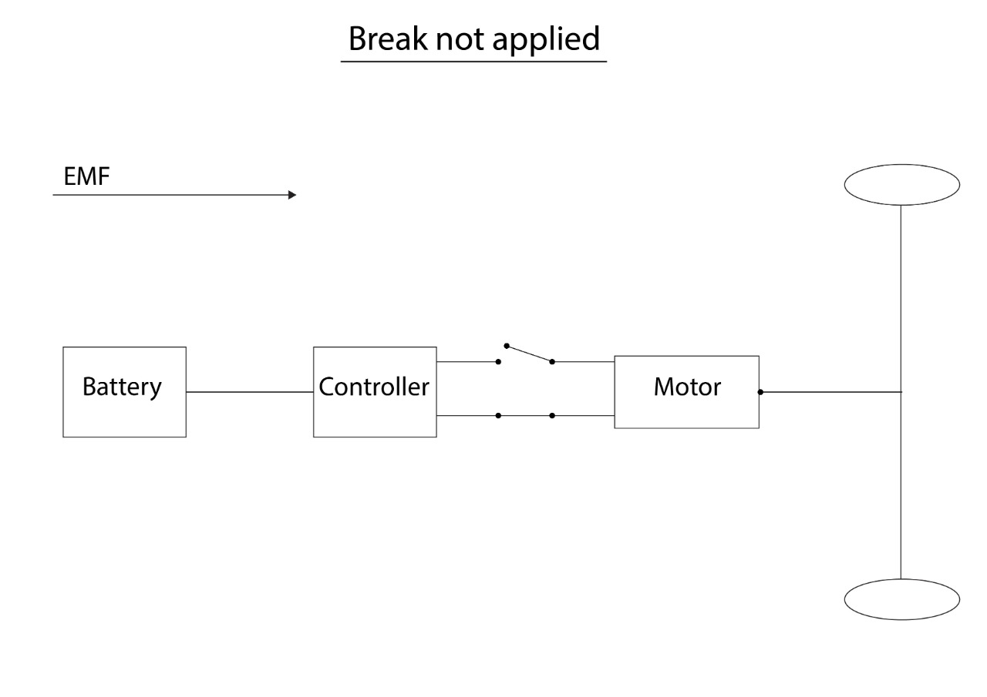

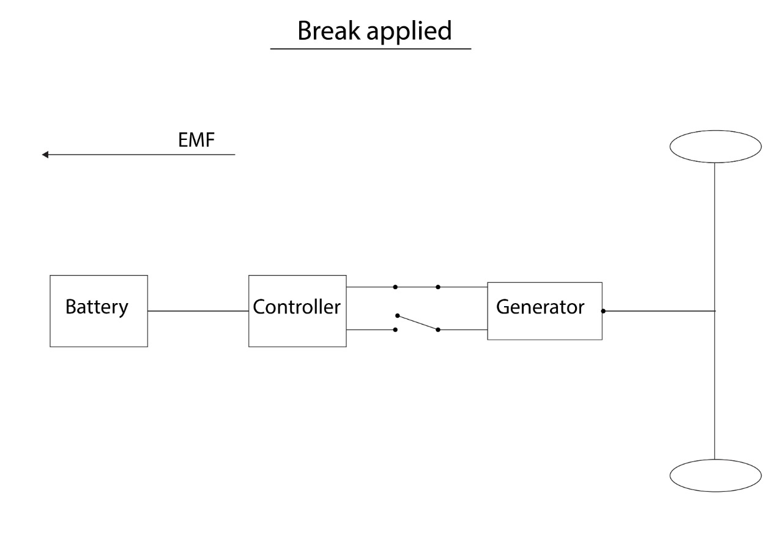

>> Upgradation of power of motor and battery – this upgradation will help in increasing the battery backup, speed of bike and overall efficiency.

>>The GPS and Bluetooth system – able to connect bike with your phone, track the bike, automatic emergency call in case of emergency, Traffic control.

>> Improved structure of the bike with proper boxing and covering of each component.

**BUDGET FOR ELECTRIC BIKE PROJECT**

|  |  |  |  |
| --- | --- | --- | --- |
| **S.NO** | **RAW MATERIAL** | **GEM PORTAL AVAILABILITY** | **TOTAL PRICE** |
| **1.** | Litium Ion Battery (  42 Ah to 52 AH ) | **NO** | **₹40,000/-** |
| **2.** | Bike Tool Kit ( BLDC  HUB Motor, Aluminium Body 12  tube Controller, Full Throttle Set / Pedal Odometer LCD Type, ignition Switch, Charging Socket, AC to DC Converter, Front Bearing, Central Locking Device) | **NO** | **₹30,000/-** |
| **3.** | GPS and Bluetooth System | **NO** | **₹10,000/-** |
| **4.** | Regenerative Braking System Kit | **NO** | **₹40,000/-** |
| **5.** | Modelling of E-Bike | **NO** | **₹20,000/-** |
| **6.** | Miscellaneous | **NO** | **₹20,000/-** |
| **TOTAL PRICE (GST INCLUDED )** | | | **₹2,04,800/-** |

**REFERENCES**

**>>** [**https://www.indiamart.com/proddetail/60v-40ah-electric-bike-lithium-ion-battery-pack-22451587691.html**](https://www.indiamart.com/proddetail/60v-40ah-electric-bike-lithium-ion-battery-pack-22451587691.html)

**>>** [**https://www.indiamart.com/proddetail/48-60v-1200w-16-17-18-inch-hub-motor-drum-brake-e-bike-kit-khetaan-make-23057097562.html**](https://www.indiamart.com/proddetail/48-60v-1200w-16-17-18-inch-hub-motor-drum-brake-e-bike-kit-khetaan-make-23057097562.html)

**>>**[**https://www.freepatentsonline.com/y2015/0258898.html#:~:text=A%20regenerative%20brake%20control%20system%20of%20an%20electric,such%20that%20the%20electric%20motor%20generates%20regenerative%20torque**](https://www.freepatentsonline.com/y2015/0258898.html#:~:text=A%20regenerative%20brake%20control%20system%20of%20an%20electric,such%20that%20the%20electric%20motor%20generates%20regenerative%20torque)**.**

**>>**[**https://www.youtube.com/results?search_query=regenerative+braking+system+in+bike**](https://www.youtube.com/results?search_query=regenerative+braking+system+in+bike)

**>>** [**https://e-vehicleinfo.com/regenerative-braking-system-in-electric-vehicles/**](https://e-vehicleinfo.com/regenerative-braking-system-in-electric-vehicles/)